SIMATS ENGINEERING
ASSESSMENT TOOL 2

COURSE NAME: INTERNET PROGRAMMING
COURSE CODE: CSA43

COURSE OUTCOME COVERED

CO -2: Apply CSS layout and styling techniques to create visually appealing and responsive web interfaces, and use JavaScript to enable interactive client-side behavior. (L3)

Assessment Tool : Design Task

Weightage: 20%

QUESTIONS: Total Marks: 20

Question 1: Responsive Navigation Bar Design - Marks (4)
Suppose that an e-commerce website requires a responsive navigation bar that adapts across desktop, tablet, and mobile devices.
(a) Identify key components required in a navigation bar for an e-commerce website.
(b) Design a responsive navigation bar using appropriate CSS techniques.
(c) Demonstrate how the navigation adapts to smaller screens (e.g., hamburger menu).
(d) Evaluate the usability and suggest improvements for better user experience.

Question 2: Product Hover Effect - Marks(4)
Suppose that an e-commerce website wants to enhance user interaction through visual effects on product items.
(a) Identify suitable CSS properties for hover effects.
(b) Suggest appropriate CSS animation or transition for product interaction.
(c) Design a hover effect for a product card.
(d) Evaluate performance and user experience considerations.

Question 3: Layout Selection (Flexbox vs Grid) - Marks (4)
Suppose that a dashboard layout needs to be designed for a web application.
(a) Identify layout requirements of a dashboard (rows, columns, alignment).
(b) Compare Flexbox and Grid based on layout needs.
(c) Choose the most suitable layout technique and justify your choice.
(d) Evaluate the scalability and responsiveness of the chosen approach.

Question 4: Mobile-First Blog Layout - Marks (4)
Suppose that a blog page must be designed following a mobile-first approach.
(a) Identify key sections of a blog layout.
(b) Design a mobile-first layout using CSS.
(c) Demonstrate how the layout scales for larger screens using media queries.
(d) Evaluate accessibility and readability of the design.

Question 5: JavaScript Event Handling for Dynamic Menu - Marks (4)
Suppose that a website includes a dynamic menu that responds to user interactions.
(a) Identify appropriate JavaScript events for menu interaction.
(b) Design event handling logic for menu toggle functionality.
(c) Implement interaction for user actions (click/hover).
(d) Evaluate performance and suggest improvements.

Code of Conduct:

I N. Meghana(192411129) certify that this submission is my original work and that I have adhered to the guidelines specified for this assessment. I understand that any violation of academic integrity rules will result in disciplinary action.

Signature of the student: N. Meghana

RUBRICS FOR CALCULATION:

Criteria | Weightage (%) | Level 4 – Exemplary (4) | Level 3 – Proficient (3) | Level 2 – Developing (2) | Level 1 – Beginning (1)
Understanding of Concept | 25 | Demonstrates complete understanding of design requirements and concepts | Good understanding with minor gaps | Basic understanding with some errors | Poor understanding or incorrect concepts
Design / Implementation | 30 | Well-structured, efficient, and responsive design implementation | Correct implementation with minor issues | Basic implementation with inconsistencies | Incorrect or incomplete implementation
Use of Tools (CSS/JS) | 20 | Effective and advanced use of tools/techniques | Appropriate use of tools | Limited or inconsistent use | Incorrect or minimal use
Analysis & Evaluation | 15 | Insightful analysis with strong justification and optimization | Good analysis with justification | Basic analysis with limited depth | Poor or no analysis
Documentation / Clarity | 10 | Clear, well-structured, and properly presented solution | Mostly clear with minor issues | Basic clarity, missing details | Poor or unclear documentation

Question 1: Responsive Navigation Bar Design [Marks: 4]
Scenario: An e-commerce website requires a responsive navigation bar that adapts across desktop, tablet, and mobile devices.
(a) Key components of an e-commerce navigation bar:
- Brand logo — links back to the homepage and anchors the left side of the bar.
- Primary navigation links — Home, Shop / Categories, Deals, About, Contact.
- Search bar — a prominent input for product discovery, often expandable on smaller screens.
- User account icon — login / profile / order history access.
- Shopping cart icon with item-count badge — always visible for quick checkout access.
- Hamburger toggle — appears only below the tablet breakpoint to house the collapsed menu.
(b) Responsive design using CSS (Flexbox-based navbar):
/* Base (mobile-first) styles */
.navbar {
display: flex;
align-items: center;
justify-content: space-between;
padding: 0.75rem 1.25rem;
background: #ffffff;
box-shadow: 0 1px 4px rgba(0,0,0,0.08);
position: sticky; top: 0; z-index: 100;
}
.navbar__links {
display: none; /* hidden on mobile until toggled */
flex-direction: column;
}
.navbar__links.open { display: flex; }
/* Tablet and above: show links inline */
@media (min-width: 768px) {
.navbar__links {
display: flex;
flex-direction: row;
gap: 1.5rem;
}
.navbar__toggle { display: none; }
}
(c) Adapting to smaller screens (hamburger menu):
Below 768px, the horizontal link list is removed from normal flow (display:none) and replaced with a single hamburger icon button. Clicking the icon toggles an .open class that reveals the links as a full-width dropdown panel beneath the bar, so the layout collapses from a wide multi-item row into a compact single-column stack. The figure below shows the same navbar rendered at desktop, tablet, and mobile widths.
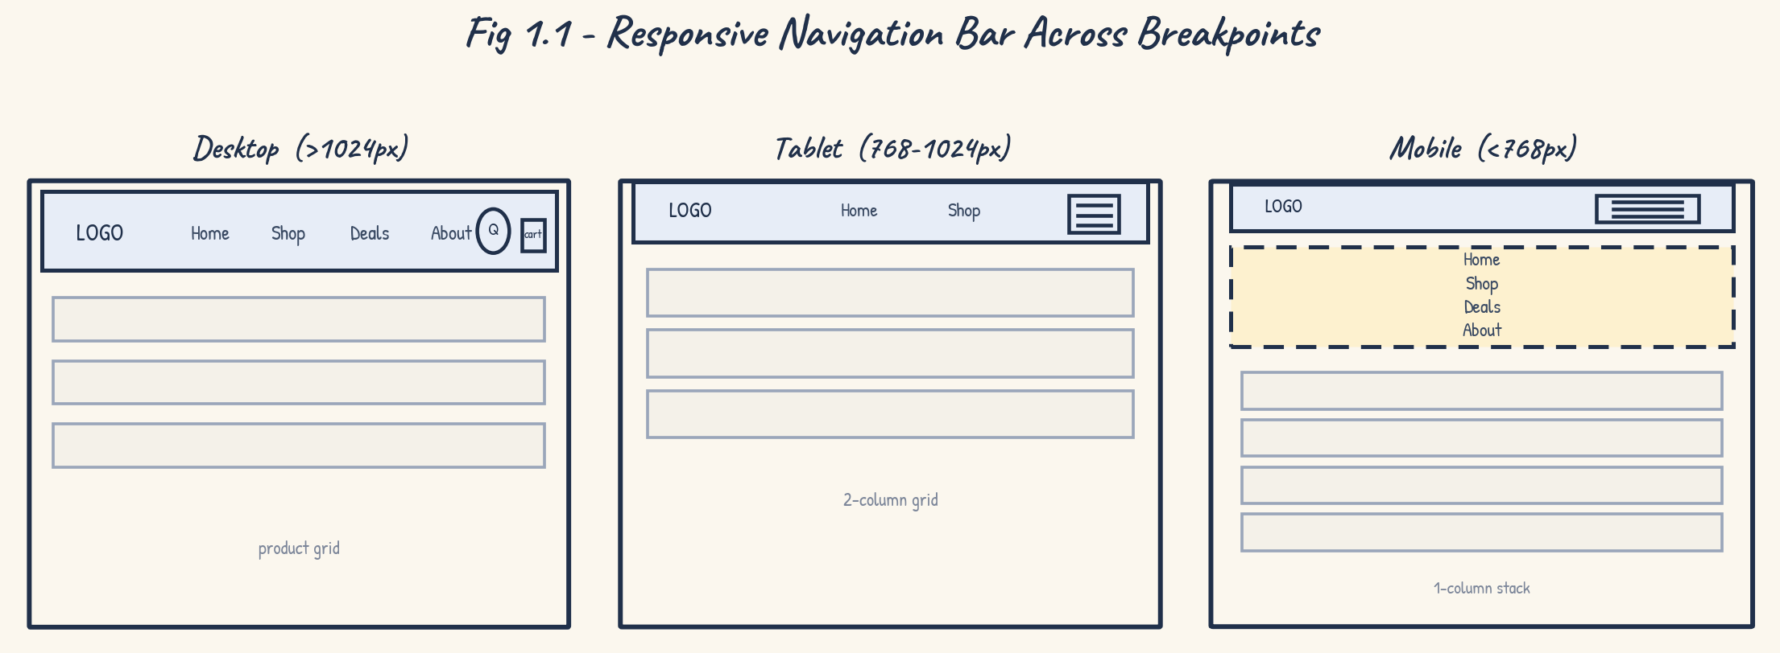
Fig 1.1 — Responsive navigation bar across desktop, tablet, and mobile breakpoints.
(d) Usability evaluation and improvements:
The design keeps core actions (search, cart) visible at every breakpoint, which supports fast task completion. However, a few refinements would improve the experience:
- Ensure tap targets on the hamburger and cart icons are at least 44×44px for comfortable touch use.
- Add an aria-expanded attribute and keyboard support (Enter/Space) so the toggle is accessible via screen readers.
- Animate the dropdown open/close with a short CSS transition instead of an abrupt display switch, to reduce perceived jank.
- Consider a persistent bottom navigation bar on mobile for cart/search, since top-of-screen controls are harder to reach one-handed on large phones.
Question 2: Product Hover Effect [Marks: 4]
Scenario: An e-commerce website wants to enhance user interaction through visual effects on product items.
(a) Suitable CSS properties for hover effects:
- transform (scale, translateY) — lifts or enlarges the card without affecting page layout.
- box-shadow — adds depth to reinforce the 'lifted' state.
- opacity / background — used to fade in an overlay or call-to-action button.
- filter (brightness, blur) — subtle emphasis on the product image.
- transition — controls the timing/easing between default and hover states.
(b) Suggested CSS transition/animation:
A short, GPU-accelerated transition on transform and box-shadow (0.25s–0.3s, ease-out) feels responsive without being distracting:
.product-card {
transition: transform 0.28s ease, box-shadow 0.28s ease;
will-change: transform;
}
.product-card:hover {
transform: translateY(-6px) scale(1.05);
box-shadow: 0 12px 24px rgba(0,0,0,0.18);
}
.product-card__overlay {
opacity: 0;
transition: opacity 0.25s ease;
}
.product-card:hover .product-card__overlay {
opacity: 1;
}
(c) Hover effect design for a product card:
On hover, the card lifts and scales slightly, a soft shadow appears beneath it, and a semi-transparent overlay fades in over the product image with an 'Add to Cart' button — giving the shopper an immediate, discoverable call to action without cluttering the default view.
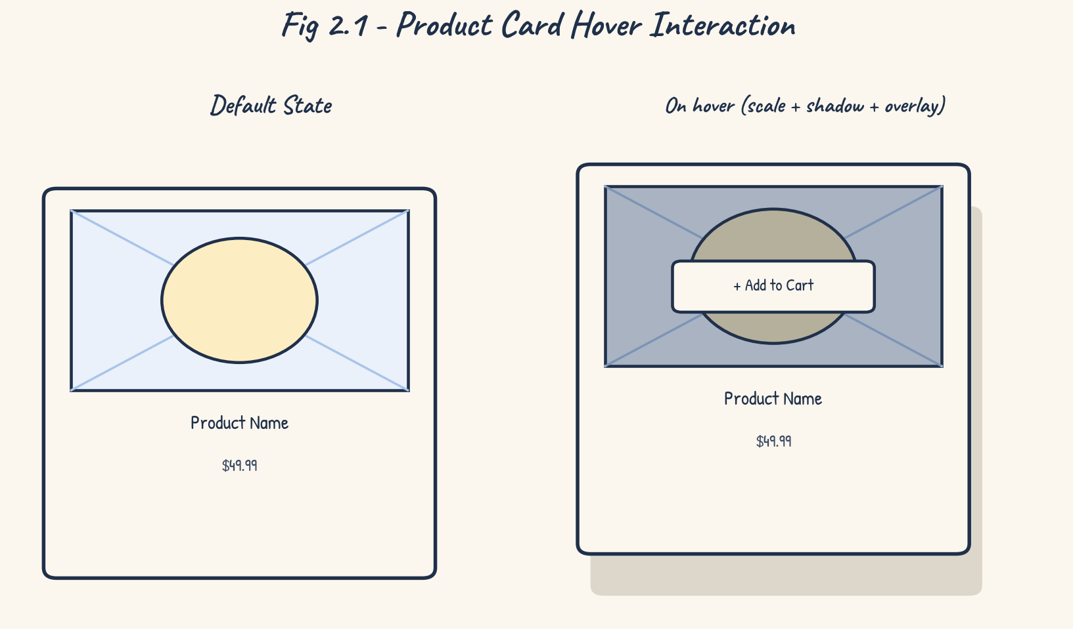
Fig 2.1 — Product card default state vs :hover state (scale, shadow, overlay, and CTA button).
(d) Performance and UX evaluation:
- Animating only transform and opacity keeps the effect on the GPU compositor and avoids expensive layout/reflow, so it stays smooth even on large grids of products.
- Hover states have no equivalent on touch devices, so the Add-to-Cart action should also be reachable via tap (e.g., always-visible icon on mobile) rather than hover-only.
- Keep the scale factor modest (around 1.03–1.06) — larger scaling can cause neighbouring cards to visually overlap and feel jarring.
- Respect prefers-reduced-motion so users sensitive to motion are not shown the scale/lift animation.
Question 3: Layout Selection (Flexbox vs Grid) [Marks: 4]
Scenario: A dashboard layout needs to be designed for a web application.
(a) Layout requirements of a dashboard:
- A full-width header/toolbar row.
- A fixed-width sidebar for navigation, running alongside the main content.
- Multiple stat/KPI cards that align in a row and in columns with the chart below them.
- A large chart or activity panel and a data table, both needing precise row/column alignment with surrounding widgets.
(b) Flexbox vs Grid comparison:
Aspect | Flexbox | CSS Grid
Axis | One dimension at a time (row OR column) | Two dimensions simultaneously (rows AND columns)
Best for | Nav bars, button groups, simple content flows | Whole-page/dashboard layouts with defined regions
Alignment | Great for distributing items along one axis | Great for aligning items across a full grid/matrix
Overlap of widgets | Difficult to align items across rows precisely | Easy — items can span multiple rows/columns via grid-template-areas
Responsiveness | flex-wrap reflows items | Redefine grid-template-columns/areas per breakpoint

(c) Chosen technique and justification:
CSS Grid is the more suitable choice for the dashboard as a whole, because the layout needs simultaneous control over rows and columns — the sidebar must span the full content height while stat cards, a chart, and a table align in a strict two-dimensional structure. Flexbox remains useful inside individual widgets (e.g., laying out icons and labels within a single stat card), so the two are combined: Grid for the page skeleton, Flexbox for micro-layouts within components.
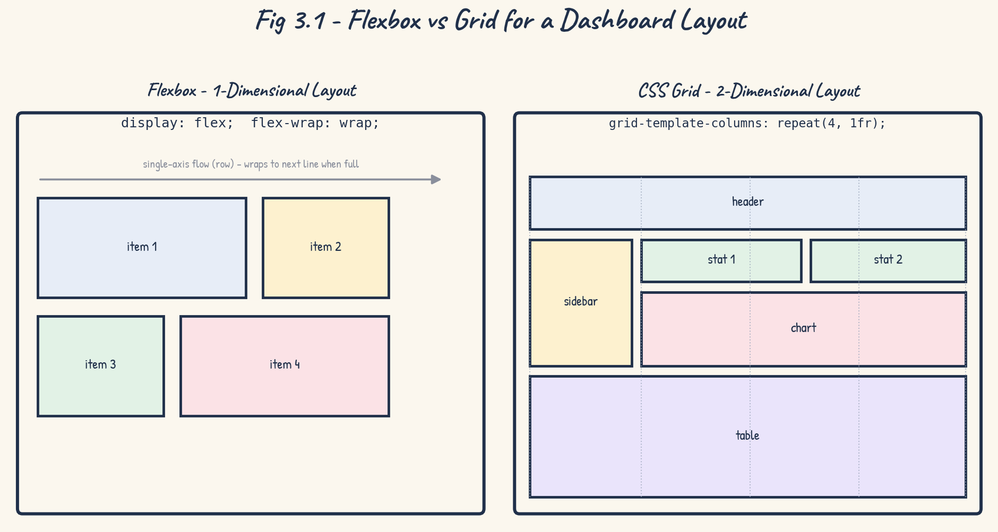
Fig 3.1 — Flexbox (single-axis) vs Grid (two-axis) applied to the same dashboard content.
(d) Scalability and responsiveness evaluation:
- Using grid-template-areas makes the layout self-documenting and lets each breakpoint simply re-map named areas rather than reordering markup.
- Grid scales well as more widgets are added — new named areas slot into the template without restructuring existing rules.
- On narrow screens, grid-template-columns can collapse to a single column and the sidebar area can be re-mapped below the header, preserving readability on mobile.
Question 4: Mobile-First Blog Layout [Marks: 4]
Scenario: A blog page must be designed following a mobile-first approach.
(a) Key sections of a blog layout:
- Header / site navigation.
- Hero or featured post banner.
- Post list / post grid (title, excerpt, thumbnail).
- Sidebar — categories, tags, search, recent posts.
- Footer — links, copyright, social icons.
(b) Mobile-first CSS design:
Base (un-media-queried) rules target the smallest screens first, stacking every section in a single column; larger layouts are then progressively added with min-width media queries:
/* Base styles = mobile */
.blog-container {
display: flex;
flex-direction: column;
gap: 1rem;
padding: 1rem;
}
.post-list { display: grid; grid-template-columns: 1fr; gap: 1rem; }
/* Tablet and up */
@media (min-width: 600px) {
.post-list { grid-template-columns: repeat(2, 1fr); }
}
/* Desktop and up */
@media (min-width: 1024px) {
.blog-container {
display: grid;
grid-template-columns: 3fr 1fr;
grid-template-areas: 'main sidebar' 'footer footer';
}
.post-list { grid-template-columns: repeat(3, 1fr); }
}
(c) Scaling for larger screens:
As viewport width increases past the 600px and 1024px breakpoints, the single-column post stack becomes a 2-column, then 3-column grid, and the sidebar moves from below the content (mobile) to sitting alongside it as a fixed-width aside (desktop) — without altering the underlying HTML.
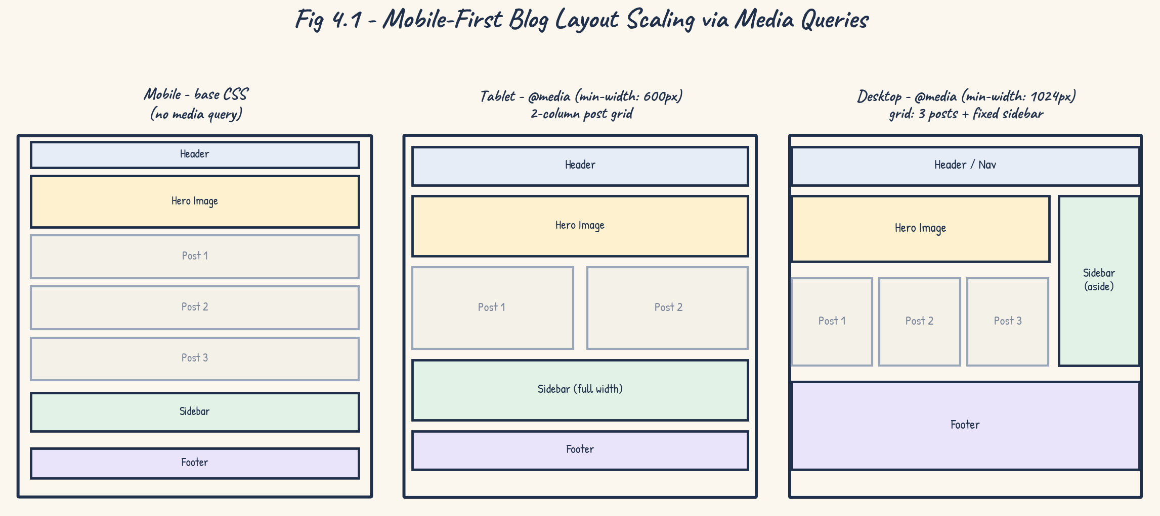
Fig 4.1 — Mobile-first blog layout scaling from a single-column stack to a multi-column desktop grid.
(d) Accessibility and readability evaluation:
- Use semantic HTML5 elements (header, nav, main, article, aside, footer) so screen readers can navigate the page structure directly.
- Set base font-size with rem units and a comfortable line-height (around 1.5–1.6) for long-form reading on small screens.
- Maintain sufficient colour contrast between text and background (WCAG AA, 4.5:1) across all breakpoints.
- Provide a 'skip to content' link so keyboard users can bypass repeated navigation on every page load.
Question 5: JavaScript Event Handling for Dynamic Menu [Marks: 4]
Scenario: A website includes a dynamic menu that responds to user interactions.
(a) Appropriate JavaScript events for menu interaction:
- click — toggles the menu open/closed on the hamburger icon.
- keydown (Enter / Space) — allows keyboard users to activate the same toggle.
- mouseenter / mouseleave — used for desktop dropdown sub-menus on hover.
- transitionend — used to run follow-up logic (e.g. focus management) after the open/close animation finishes.
- click on document (outside the menu) — used to auto-close an open menu.
(b) Event handling logic design:
The toggle button listens for a click, checks the menu's current state via a CSS class, then flips that class and updates the corresponding ARIA attribute so assistive technology stays in sync with the visual state.
const toggleBtn = document.querySelector('.navbar__toggle');
const menu = document.querySelector('.navbar__links');
function toggleMenu(event) {
const isOpen = menu.classList.contains('open');
menu.classList.toggle('open', !isOpen);
toggleBtn.setAttribute('aria-expanded', String(!isOpen));
}
toggleBtn.addEventListener('click', toggleMenu);
toggleBtn.addEventListener('keydown', (e) => {
if (e.key === 'Enter' || e.key === ' ') {
e.preventDefault();
toggleMenu(e);
}
});
(c) Implementing the interaction:
The flow below traces a single click from the moment the listener is registered through to the menu being re-rendered on screen, including the branch that decides whether the menu should open or collapse.
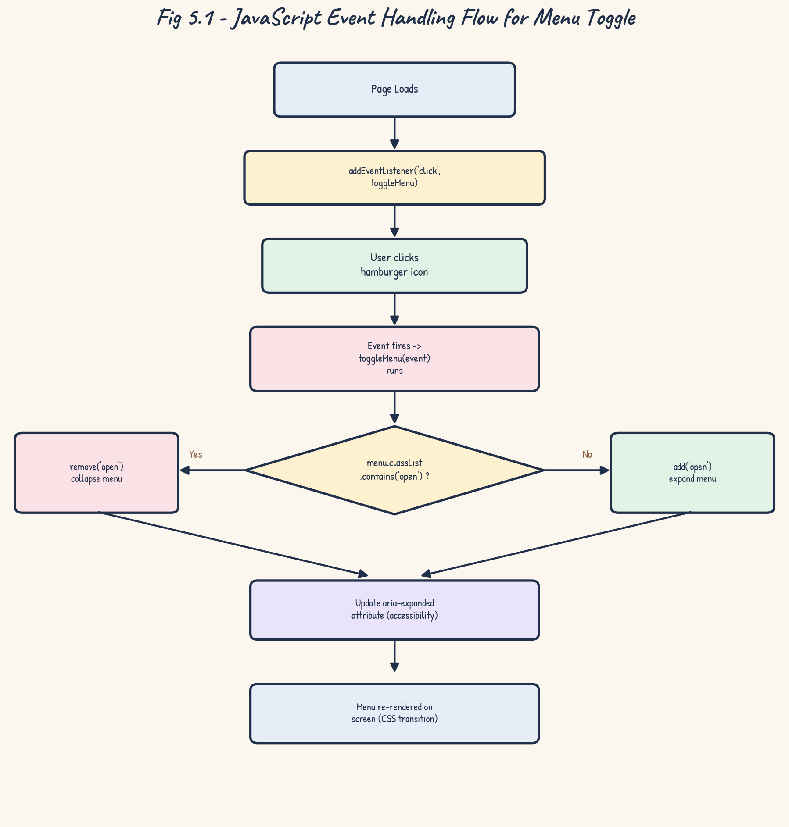
Fig 5.1 — JavaScript event handling flow for the dynamic menu toggle.
(d) Performance evaluation and improvements:
- Attach a single listener to the toggle button (or use event delegation on a parent container) rather than binding separate handlers to every menu item.
- Toggle a class instead of directly manipulating inline styles or the DOM structure — this keeps style changes cheap and centralised in CSS.
- Debounce or throttle any resize/scroll listeners tied to the menu so they don't fire excessively during continuous events.
- Use passive: true for touch/scroll listeners that don't call preventDefault, so the browser can scroll smoothly without waiting on the handler.

